

Uber Data Analytics Analyzing data and arriving at better solutions through machine learning
By : Sultan Ahmad Qarqash
ID:202120556
Department of Business Intelligence and Data
Analytics
Graduation Project in Business Intelligence and Data Analytics
Introductio
In recent years, ride-booking and delivery applications such as Uber, Careem, and similar platforms have become widely used both globally and in Jordan. These applications are now part of people’s daily lives, offering convenient, fast, and relatively safe transportation solutions. This rapid growth represents a significant transformation in how individuals move within cities, making transportation more accessible and efficient. Despite these advantages, these platforms are not without challenges. Issues such as trip cancellations, delays, pricing inconsistencies, and variations in service quality can negatively impact user experience and operational efficiency. Understanding these challenges is essential for improving the performance of such systems and ensuring customer satisfaction. This project aims to analyze ride booking data to better understand user behavior and identify key factors that influence booking outcomes, especially cancellations. By applying data analysis techniques and machine learning models, the project seeks to uncover patterns, generate insights, and predict whether a ride will be completed or canceled. The ultimate goal of this study is to provide data-driven solutions that help reduce common issues, enhance service quality, and support better decision-making in ride-booking systems.

Dataset Overview
The dataset captures 148,770 total bookings across multiple vehicle types and provides a complete view of ride-sharing operations including successful rides, cancellations, customer behaviors, and financial metrics. Key Statistics:
- Total Bookings: 148.77K rides
- Success Rate: 65.96% (93K completed rides)
- Cancellation Rate: 25% (37.43K cancelled bookings)
- Customer Cancellations: 19.15% (27K rides)
- Driver Cancellations: 7.45% (10.5K rides)

Column Name | Description
Date | Date of the booking
Time | Time of the booking
Booking ID | Unique identifier for each ride booking

Column Name | Description
Booking Status | Status of booking (Completed, Cancelled by Customer,  Cancelled by Driver, etc.)
Customer ID | Unique identifier for customers
Vehicle Type | Type of vehicle (Go Mini, Go Sedan, Auto, eBike/Bike,  UberXL, Premier Sedan)
Pickup Location | Starting location of the ride
Drop Location | Destination location of the ride
Avg VTAT | Average time for driver to reach pickup location (in minutes)
Avg CTAT | Average trip duration from pickup to destination (in minutes)
Cancelled Rides by  Customer | Customer-initiated cancellation flag

Column Name | Description
Reason for cancelling by  Customer | Reason for customer cancellation
Cancelled Rides by Driver | Driver-initiated cancellation flag
Driver Cancellation Reason | Reason for driver cancellation
Incomplete Rides | Incomplete ride flag
Incomplete Rides Reason | Reason for incomplete rides
Booking Value | Total fare amount for the ride
Ride Distance | Distance covered during the ride (in km)
Driver Ratings | Rating given to driver (1-5 scale)
Column Name | Description
Customer Rating | Rating given by customer (1-5 scale)
Payment Method | Method used for payment (UPI, Cash, Credit Card, Uber  Wallet, Debit Card)

Vehicle Fleet Coverage
Vehicle Type | Total  Bookings | Success  Rate | Avg  Distance | Total  Distance
Auto | 12.88M | 91.1% | 25.99 km | 602K km
eBike/Bike | 11.46M | 91.1% | 26.11 km | 537K km
Go Mini | 10.34M | 91.0% | 25.99 km | 482K km
Go Sedan | 9.37M | 91.1% | 25.98 km | 433K km
Premier  Sedan | 6.28M | 91.2% | 25.95 km | 292K km
UberXL | 1.53M | 92.2% | 25.72 km | 72K km

Revenue Distribution by Payment Method
UPI: Highest contributor (~40% of total revenue)
Cash: Second highest (~25% of total revenue)
Credit Card: ~15% of total revenue
Uber Wallet: ~12% of total revenue
Debit Card: ~8% of total revenue

Cancellation Patterns
Customer Cancellation Reasons:
- Wrong Address: 22.5%
- Driver Issues: 22.4%
- Driver Not Moving: 22.2%
- Change of Plans: 21.9%
- App Issues: 11.0%
Driver Cancellation Reasons:
- Capacity Issues: 25.0%
- Customer Related Issues: 25.3%
- Personal & Car Issues: 24.9%
- Customer Behavior: 24.8%
Rating Analysis
- Customer Ratings: Consistently high across all vehicle types (4.40-4.41)
- Driver Ratings: Slightly lower but stable (4.23-4.24)
- Highest Rated: Go Sedan (4.41 customer rating)
- Most Satisfied Drivers: UberXL category (4.24 rating)
Data Quality
- Completeness: Comprehensive coverage with minimal missing values
- Consistency: Standardized vehicle types and status categories
- Temporal Coverage: Full year 2024 data with daily granularity
- Geographic Scope: Multiple pickup and drop locations
- Balanced Distribution: Good representation across all vehicle types and time periods.

Pickup → Drop transportation network for areas in Delhi / Gurgaon / Noida
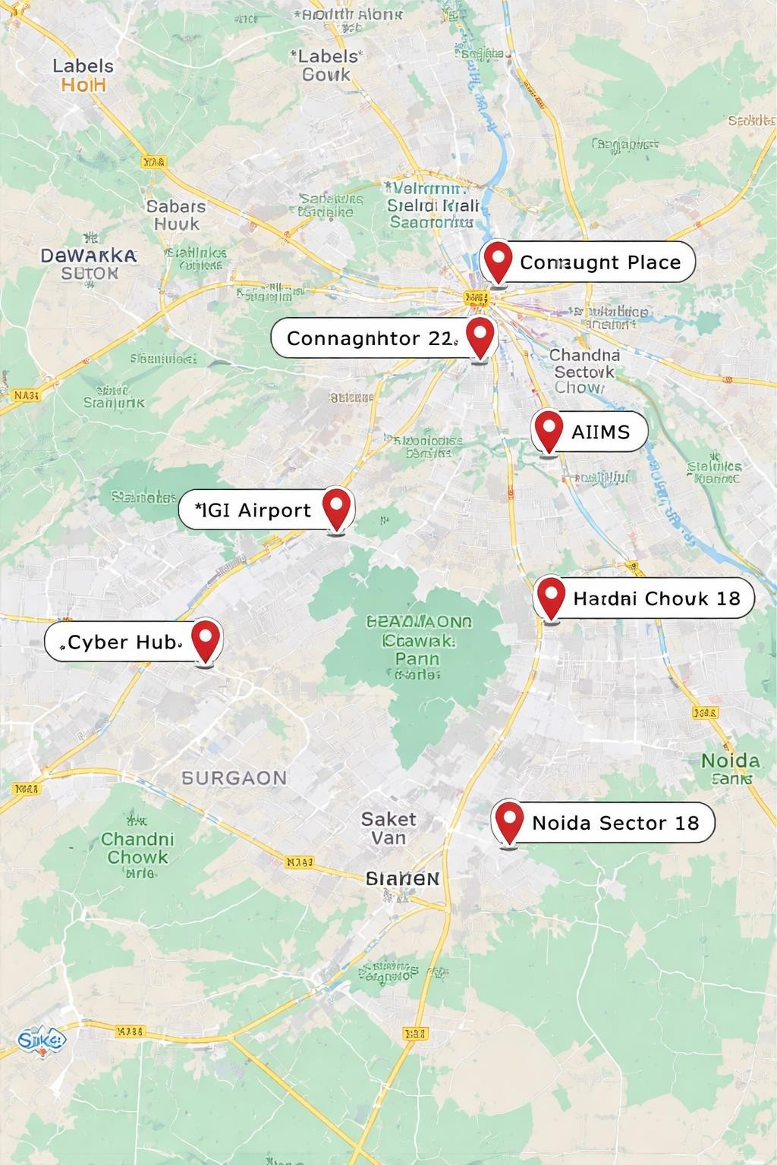

1-Core Locations
Connaught Place
Location: Central New Delhi Why it’s important:
- Commercial and administrative center
- Major transportation hub
- Very high traffic densit


2- Cyber Hub (Gurgaon)
Location: Gurgaon
Why it’s important:
- Modern business district
- High concentration of offices and restaurants
- Strong day and night activity
3- IGI Airport (Indira Gandhi International Airport)

- Location: New Delhi Why it’s important: Main international airport
- Major travel hub
- Very high passenger demand


4- AIIMS
Why it’s important:
- One of the largest hospitals in India
- Continuous movement (patients, staff, students)
- High transportation demand
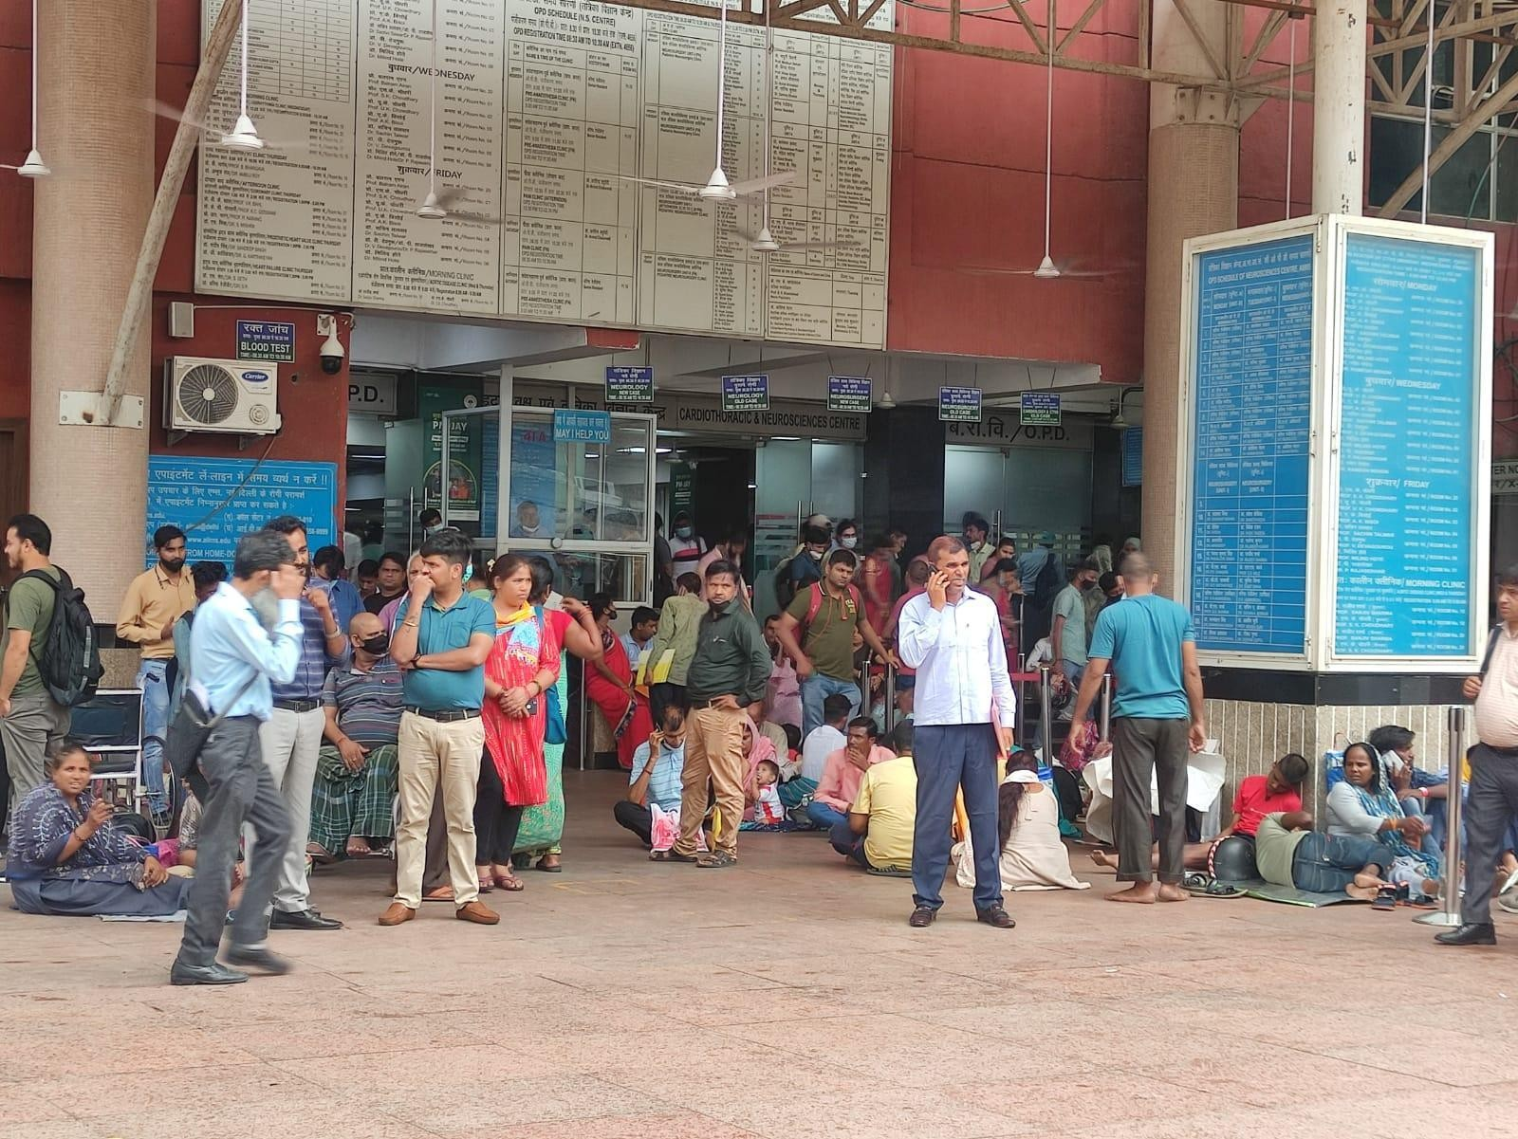

5- Noida Sector 18
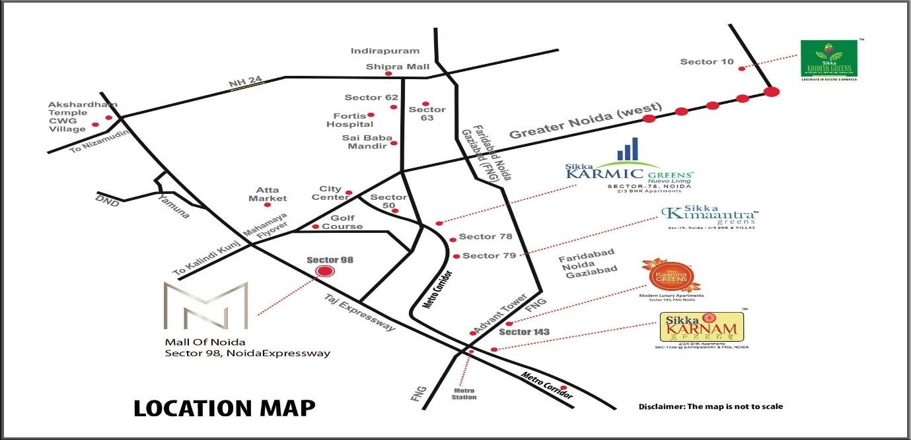
Location: West Delhi
Why it’s important:
- Large residential area
- Close to airport connectivity • Frequent daily commuting
6- Dwarka Sector 21
Location: West Delhi Why it’s important:
- Large residential area
- Close to airport connectivity
- Frequent daily commuting


7- Chandni Chowk

Location: Old Delhi Why it’s important:
- Historic market area
- Extremely high population density
- Heavy traffic and congestion


8- Saket



Location: South Delhi
Why it’s important:
- Mixed residential and commercial area
- Popular shopping destinations
- Moderate to high demand

Data cleaning
Before cleaning
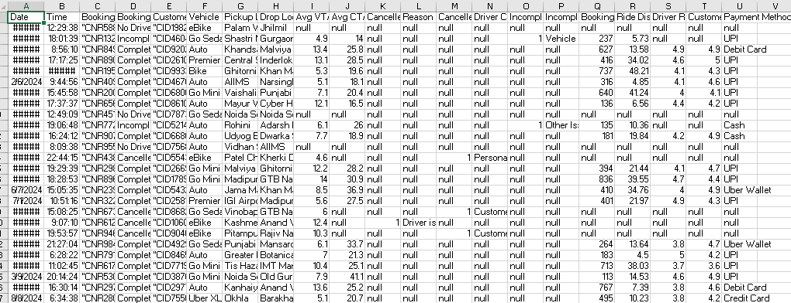
- After verifying the data, it was found that there were no duplicates.
- In the Booking Value column, I filled in the empty values with the lowest trip price, then converted the currency from Indian rupees to US dollars.
- In the Customer Rating column and the Driver Rating column, I filled in the empty values with the arithmetic mean of the result.
-In the riding distance column, I filled in the empty values with the arithmetic mean of the result.
-In the Average Access Time and Average Access Time columns, I filled in the empty values with the arithmetic mean of the result.
-In the columns "Trips Cancelled by Customer", "Reason for Cancellation by Customer", "Trips Cancelled by Driver", "Reason for Driver Cancellation", "Trips Not Completed", and "Reason for -Not Completed Trips", I filled the empty values with the word "Completed".
-In the "Payment Method" column, I filled in the empty values with the word "Unpaid".
-Each column was converted to a number or text.
- The data was sorted by date from oldest to newest.

After cleaning
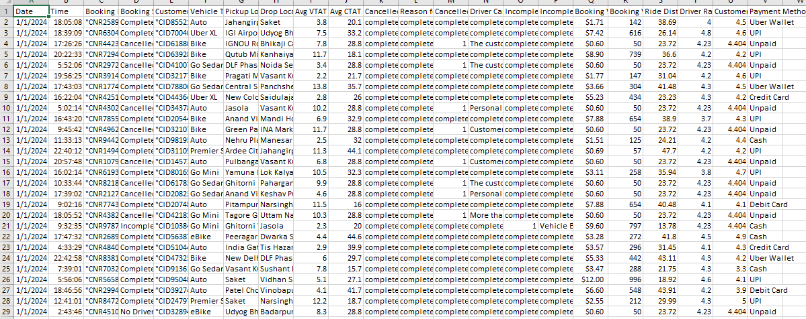
Descriptive Analysis
-Number of delivery orders during each month
Row Labels | Count of Booking  ID
<1/1/2024

Jan 12861
Feb 11927
 | Mar | 12719
 | Apr | 12199
 | May | 12778
 | Jun | 12440
 | Jul | 12897
 | Aug | 12636
 | Sep | 12248
 | Oct | 12651
 | Nov | 12394
 | Dec | 12250
Grand Total |  | 150000
- Number of vehicles depending on type
Row Labels | Count of Customer  ID
Auto | 37419
Bike | 22517
eBike | 10557
Go Mini | 29806
Go Sedan | 27141
Premier Sedan | 18111
Uber XL  (blank) | 4449
Grand Total | 150000

- Number of canceled delivery orders, whether by the driver or the customer
Row Labels | Count of Booking  ID
cancelled by customer | 27000
complete | 123000
cancelled by driver | 10500
complete  (blank) | 112500

- Payment Method Comparison
Cash | 25367
Credit Card | 10209
Debit Card | 8239
Uber Wallet | 12276
Unpaid | 48000
UPI 45909
(blank)
Grand Total | 150000

- Drop Location

Row Labels |  |  | Count of Booking  ID
 | Adarsh Nagar |  | 845
 | AIIMS |  | 850
 | Akshardham |  | 856
 | Ambience Mall |  | 836
 | Anand Vihar |  | 830
 | Anand Vihar ISBT |  | 784
 | Ardee City |  | 875
 | Arjangarh |  | 857
 | Ashok Park Main |  | 861
 | Ashok Vihar |  | 851

 | DLF Phase 3 |  |  | 876
 | Dwarka Mor |  |  | 867
 | Dwarka Sector 21 |  |  | 856
 | Faridabad Sector 15 |  |  | 864
 | Ghaziabad |  |  | 878
 | Ghitorni |  |  | 877
 | Ghitorni Village |  |  | 815
 | Golf Course Road |  |  | 808
 | Govindpuri |  |  | 837
 | Greater Kailash |  |  | 845
 | Greater Noida |  |  | 875
 | Green Park |  |  | 824
 | GTB Nagar |  |  | 861
 | Gurgaon Railway Station |  |  | 891
 | Gurgaon Sector 29 |  |  | 827
 | Gurgaon Sector 56 |  |  | 894
 | Gwal Pahari |  |  | 878
 | Hauz Khas |  |  | 892
 | Hauz Rani |  |  | 828
 | Hero Honda Chowk |  |  | 831
 | Huda City Centre |  |  | 774
 | Keshav Puram |  |  | 839
Grand Total |  |  | 150000

Pickup Location

Row Labels |  | Count of Booking  ID
 | Adarsh Nagar | 858
 | AIIMS | 918
 | Akshardham | 839
 | Ambience Mall | 873
 | Anand Vihar | 859
 | Anand Vihar ISBT | 831
 | Ardee City | 861
 | Arjangarh | 810
 | Ashok Park Main | 884
 | Ashok Vihar | 796
 | Ashram | 874
 | Aya Nagar | 870
 | Azadpur | 847
 | Badarpur | 921
 | Badshahpur | 868
 | Bahadurgarh | 802
 | Yamuna Bank |  | 824
(blank)

Grand Total |  | 150000

Dashboard
1-Overview
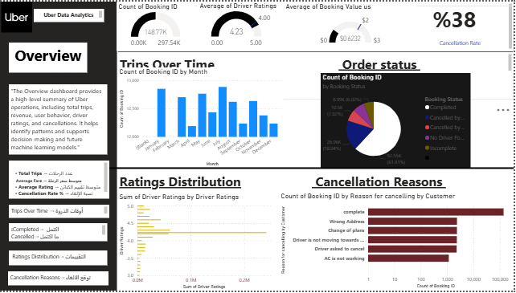
The dashboard provides a high-level summary of Uber's operations, including total trips, average driver ratings, average booking value, and cancellation rates.
• Total Trips: 148K

• Average Driver Rating: 4.23 • Average Booking Value: $0.68 • Cancellation Rate: 38%

-The dashboard provides a general description of the data to help us understand the situation
Gauge Number of orders, average captain rating, and average trip price
Column chart Trips Over Time
Pie chart
Order status
Bar chart Ratings Distribution and Cancellation Reasons

-January and July are the months with the highest delivery requests, while April and October have the lowest.
-61% of orders were completed, and most orders were cancelled by customers.
-Most of the cancelled orders were simply due to the driver's request to the customer or due to a location error

2-User Behavior
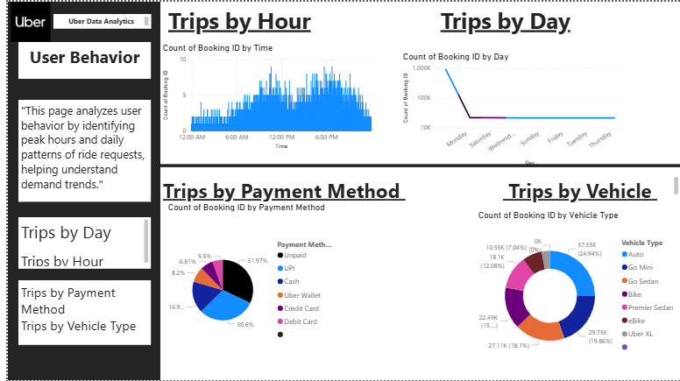

-The dashboard explains user behavior through most frequent days and hours, vehicle type, and payment method.
-Saturday and Monday are the days when orders are highest.
-Peak hours after 12 pm
-Unified Payments Interface(UPI): It is an electronic payment system in India that allows users to conduct financial transactions online securely and quickly using their mobile phones. It is the most widely used method.
-"Auto" refers to automated cars or automatic transmissions. It's a type of car that operates without the need for manual gear changes, as the gears shift automatically based on speed. Most commonly used

Line chart Trips by Day
Column chart Trips by Hour
Pie chart Trips by Payment Method
Dounat chart Trips by Payment Method

3-Map analysis
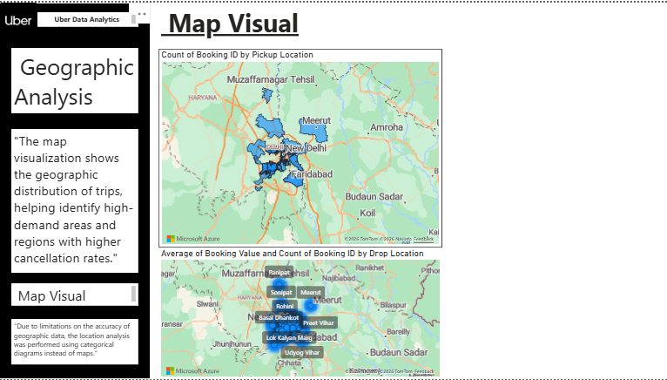
-The most popular arrival point was Ashram.
-The area that served as the starting point was Khandsa
- Map Visual - Pickup Locations:
  - This map shows the distribution of Uber trips based on pickup locations.
  - The map helps identify high-demand areas where trips are being initiated, particularly focusing on regions with a higher count of bookings.
  - Insight: The map highlights areas such as New Delhi, Faridabad, and Meerut as regions with a higher frequency of pickups, helping Uber understand where their services are in most demand.
- Map Visual - Drop-Off Locations:
  - This map visualizes the average booking value and count of bookings by drop-off locations. o It helps identify where riders are being dropped off and the correlation between drop-off locations and booking value. o Insight: Locations such as Sonipat, Meerut, and Rohini show a significant concentration of trips, helping Uber understand popular destinations and the booking values associated with these areas.

How This Analysis Can Be Used:
- Optimizing Service Coverage:
  - By analyzing pickup and drop-off locations, Uber can ensure that they have sufficient coverage in highdemand regions. This information can help in fleet management by strategically placing cars in highdemand areas.
- Targeting High-Value Areas:
  - If certain areas have a higher average booking value, Uber can focus on promotional offers or surge pricing for those regions to maximize revenue.
- Improving Operational Efficiency:
  - Identifying the geographic distribution of trips helps Uber optimize routes and better allocate resources, reducing wait times for riders and improving overall efficiency.
- Understanding Demand Trends:
  - The geographic analysis also aids in identifying trends related to trip density in different regions, enabling Uber to forecast demand patterns and scale their operations accordingly.

4-Relationships
Uber Data Analysis - Relationships Dashboard
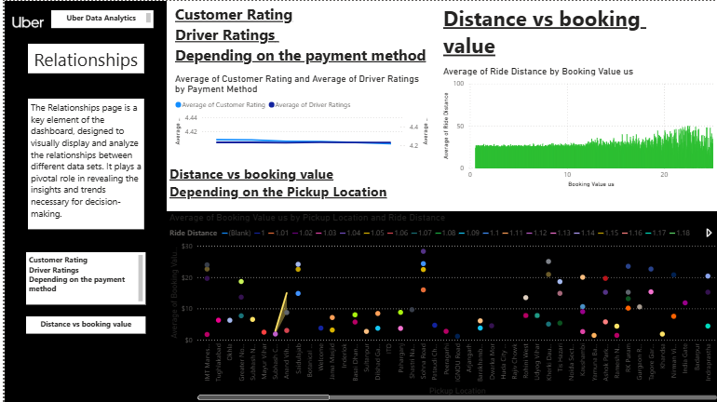
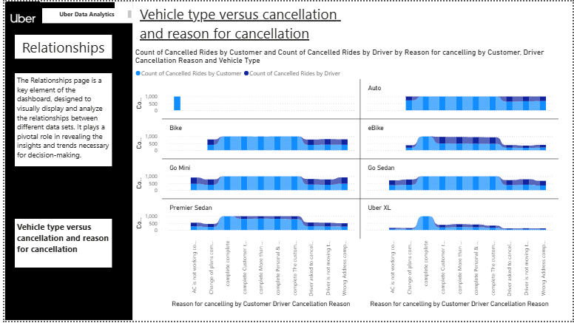

Uber Data Analysis - Relationships Dashboard
- Customer Rating and Driver Ratings Depending on Payment Method: o This section presents an analysis of customer ratings and driver ratings based on the payment method. o From the chart, we can see the average ratings for both customers and drivers, which helps in evaluating how different payment methods correlate with the quality of service. o Insight: For instance, if a specific payment method
(e.g., Cash or UPI) has a higher rating, it could
suggest that users prefer that payment method for certain reasons, like ease of use or trust in the system.
- Distance vs Booking Value Depending on the Pickup Location: o This analysis visualizes the relationship between the distance of the ride and the booking value depending on the pickup location. o The chart below shows how booking value (amount paid by the customer) varies with the pickup location and ride distance. o Insight: The scatter plot helps determine if longer distances correlate with higher booking values. This could guide Uber in optimizing fare pricing based on pickup points and the expected distance for each ride.
- Distance vs Booking Value (General):
o This visualization shows the average ride distance plotted against the booking value. o The graph indicates how fare amounts change with the ride distance, helping Uber optimize pricing strategies.

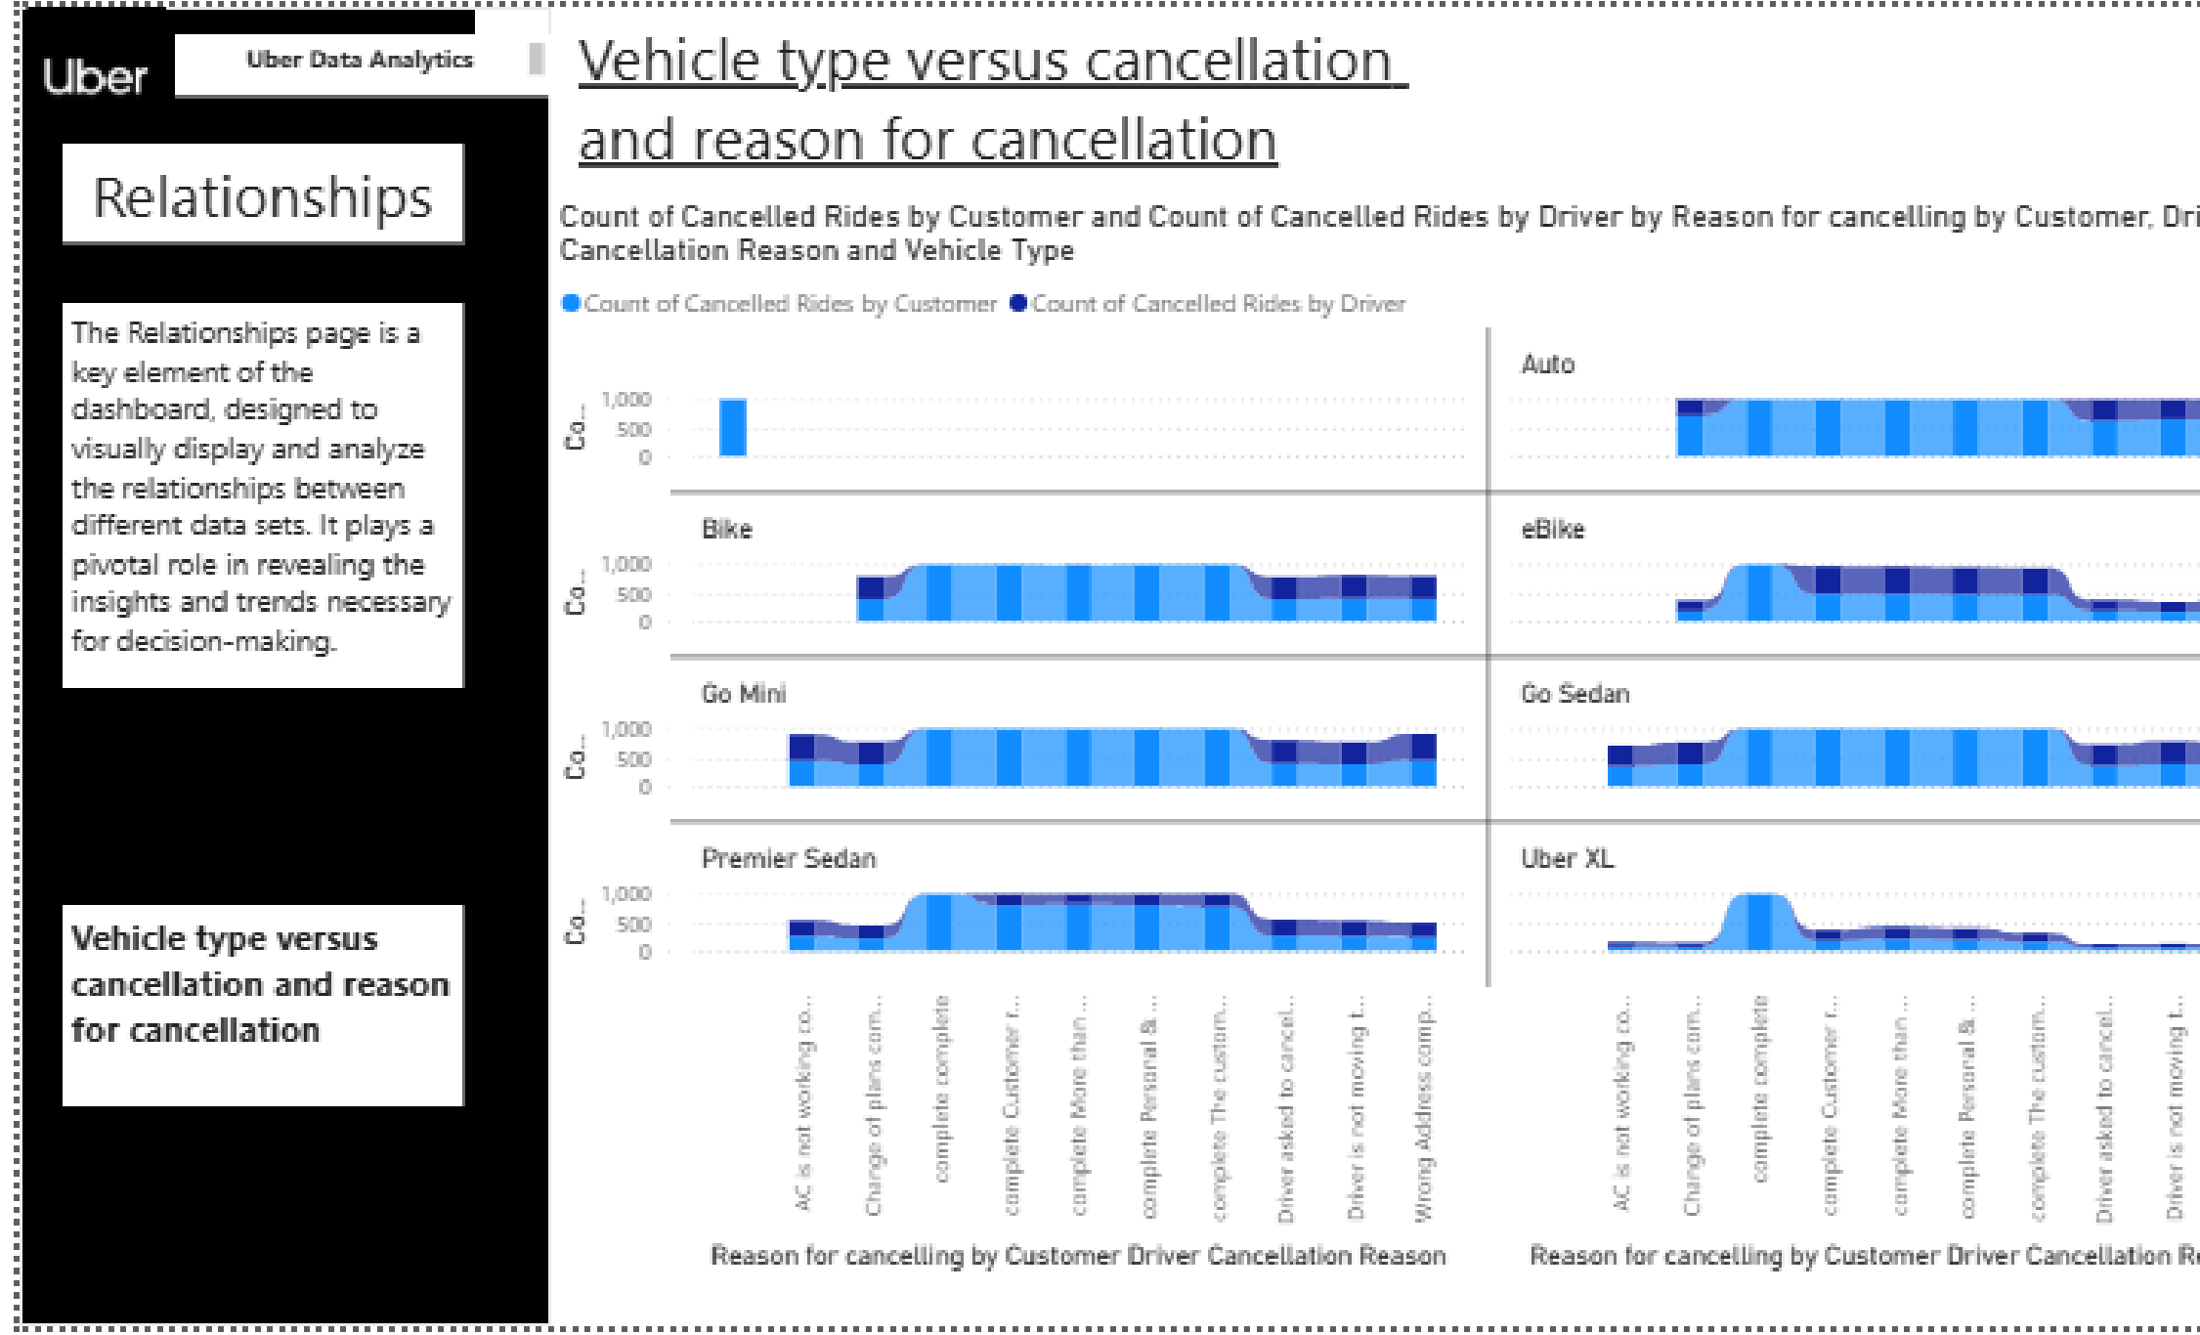
Insight: Longer distances tend to result in higher booking values, which is expected, but analyzing the variance in the data can highlight areas where pricing could be adjusted or optimized further.
Vehicle Type Versus Cancellation and Reason for Cancellation
1. Count of Cancelled Rides by Customer and Driver:
o This part of the dashboard compares the number of cancelled rides from the perspective of both the customer and the driver across different vehicle types.
The blue bars represent the cancelled rides by customers, and the darker blue bars show the cancelled rides by drivers. o Insight: By analyzing this, Uber can determine which vehicle types experience the most cancellations and understand whether it's due to customer preferences or driver-related issues.
- Reasons for Cancellation by Customer and Driver:
o Each vehicle type (e.g., Auto, Go Mini, eBike, Premier Sedan, Uber XL) is also analyzed with respect to cancellation reasons:
        - Customer Cancellation Reasons:
        - Examples might include AC not working, wrong address, or other customer preferences.
        - Driver Cancellation Reasons:
        - Examples might include driver not available, driver is late, or vehicle issues.
o These cancellation reasons are represented across different categories for each vehicle type.
- Vehicle Type Breakdown:
Auto, eBike, Go Mini, Premier Sedan, and Uber XL are evaluated based on how often cancellations occur and why they happen. o The data is visualized using bar charts to show how cancellations are distributed across vehicle types and the reasons behind these cancellations.

How This Analysis Can Be Used:
  - Identifying Problematic Vehicle Types:
o If certain vehicle types, like eBikes or Go Mini, have significantly higher customer cancellation rates, Uber can investigate further to determine whether it’s related to vehicle comfort or other factors like availability.
  - Improving Customer and Driver Experience:
o By understanding the reasons for cancellations, Uber can take action to reduce the number of cancellations. For example:
        - Driver-related issues (like "AC not working" or "vehicle not available") might require better vehicle maintenance or driver training.

        - Customer-related issues (like "wrong address" or "change of mind") could be reduced by improving the booking system or offering more accurate location services.
  - Optimizing Vehicle Fleet:
o The analysis can help Uber optimize its fleet distribution, ensuring that the right types of vehicles are available in high-demand areas and reducing the number of cancellations.
- Targeted Operational Strategies:
o If specific cancellation reasons (e.g., "AC not working") are prevalent for certain vehicles, Uber can target that vehicle type for maintenance or improvements, ensuring better customer satisfaction.

Conclusions:
  - The relationship between vehicle type and cancellation reasons provides valuable insights into areas that need attention, whether it’s due to the vehicle’s performance or customer preferences.
  - Understanding driver and customer cancellations helps Uber take proactive steps to improve both driver and rider satisfaction and reduce cancellations in the future.

AI Part
1-Introduction
In recent years, Intelligent Transportation Systems (ITS) and ride-hailing services have become the backbone of urban mobility. Companies like Uber rely heavily on datadriven technologies to maximize operational efficiency, improve customer satisfaction, and predict dynamic market demands.
Artificial Intelligence (AI) and Machine
Learning (ML) play a crucial role in analyzing massive behavioral data generated by users and drivers. This part of the project implements advanced AI methodologies, including Deep Learning through Artificial Neural Networks (ANN) and traditional Machine Learning via Decision Trees. These technologies are applied to solve core transport problems such as predicting ride frequencies, forecasting geographic demand patterns, and classifying ride cancelation behaviors to optimize real-time decisionmaking
2.-The Problem
Ride-hailing platforms suffer from high operational inefficiencies due to a major mismatch between driver supply and customer demand. This problem manifests in two critical areas
- Demand and Density Uncertainty: The inability to accurately predict the number of rides required per hour in specific geographic regions leads to prolonged customer wait times and driver loss of income during lowdemand periods
- High
Cancellation Rates: Unexpected ride cancellations by either drivers or customers create friction, reduce platform reliability, and cause significant revenue losses. Without preventative AI models, the platform cannot anticipate or minimize these structural disturbances

3-The Proposed AI Solution
To solve these challenges, we built three tailored predictive frameworks using the implementation files attached:
Ride Frequency Prediction (Regression Tasks): Employed Decision Tree Regressors and Deep Neural Networks to forecast the continuous count of rides. The regression model achieved an exceptional accuracy score of 93.76% and a very low Mean Absolute Error (MAE) of 0.119, showing robust capability in mapping dynamic variables to demand. * Spatial-Temporal Modeling (Number of rides per hour per region): Built a deep Sequential Artificial Neural Network (ANN) with multiple Dense and Dropout layers to calculate exactly how many rides will be generated in a specific region at any given hour. This deep learning model reached an operational accuracy of 93.98% with an MAE of 0.072. * Ride
Cancellation Classification (Classification Tasks): Developed a binary Neural Network classifier to pre-determine whether a requested booking will be completed or canceled/incomplete. This architecture demonstrated a remarkable testing accuracy of 99.80% and an F1-score of 1.00, allowing the platform to flag high-risk trips before dispatch.
4-Benefits and System Value
Integrating these AI models benefits the ecosystem on multiple levels:
Proactive Resource Allocation: Drivers can be dynamically navigated and positioned into future high-demand zones before the demand even rises, drastically eliminating vehicle idle time.
Enhanced Customer Experience: Reducing passenger waiting time (VTAT/CTAT) and minimizing late-stage cancellations directly builds trust and increases user retention.
Maximizing Revenue: By preemptively flagging high-risk cancellation bookings, the smart system protects the continuous cash flow and saves operational resources
5-Positive Impact on Jordan Deploying this smart framework yields localized economic and societal transformation in Jordan:
Mitigating Amman’s Traffic Congestion: Traffic jams in major Jordanian urban hubs like Amman, Irbid, and Zarqa can be dramatically alleviated. Instead of hundreds of empty ride-hailing cars cruising blindly searching for passengers, data-driven positioning ensures cars move only when and where they are needed.
Supporting the Digital Economy: Aligns directly with Jordan's National Vision for Digital Transformation by turning local gigeconomy sectors into smart digital operations.
Boosting Driver Income Security: Fuel prices are a critical concern for Jordanian captains; optimizing travel distances via AI avoids fuel wasting, maximizing net monthly profits for families relying on ride-hailing as a primary or secondary source of income.
6-Development Environment & Languages
The AI layer of this graduation project was fully implemented using Python 3 inside the Google Colaboratory cloud ecosystem. Advanced software packages were leveraged to support the data science lifecycle, such as TensorFlow / Keras for designing, stacking, and optimizing sequential Neural Network blocks. Additionally, Scikit-Learn was used for splitting, evaluating, generating classification reports, and training the Decision Tree baseline classifiers. Pandas and NumPy were utilized for cleaning and statistical transformations of the core dataset, while advanced analytical data visuals like Confusion Matrix Heatmaps and learning curves were created using Matplotlib and Seaborn

Explanation of the code
Spatial-Temporal Ride Demand Forecasting
Model using Decision Tree Regressor
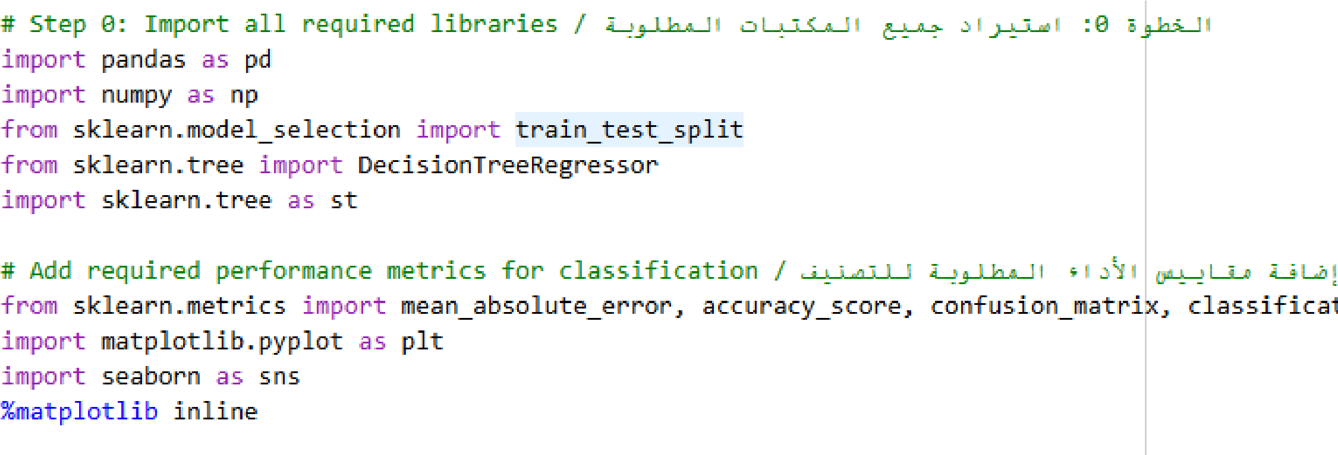
Step 1: Import all required libraries.
pandas → For handling data in tables (DataFrames) easily.
numpy → For numerical operations and arrays.
train_test_split → To split data into training and testing sets.
DecisionTreeRegressor → To create a Decision Tree model for predicting numerical values.
sklearn.tree as st → used for extra tree tools like plotting or exporting the tree.

mean_absolute_error → To calculate the absolute prediction error (for regression models).
accuracy_score, confusion_matrix, classification_report → Metrics for evaluating classification models.
matplotlib.pyplot → For plotting graphs and charts.
seaborn → A plotting library built on top of matplotlib for nicer and easier visuals. %matplotlib inline → To display plots directly inside Jupyter Notebook.

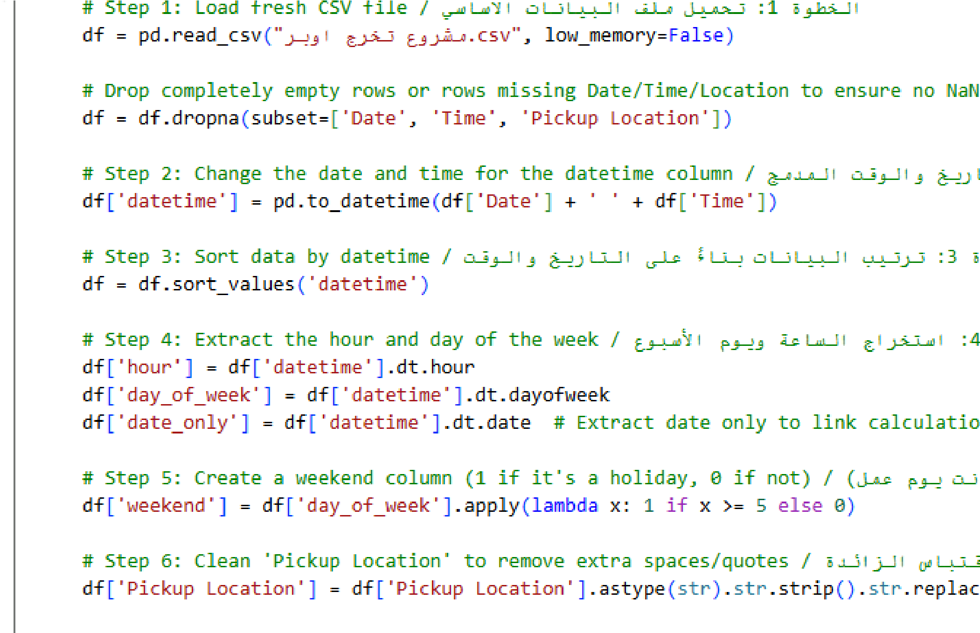
Step 2: Load and clean CSV
Loads a CSV file into a pandas DataFrame called df.
low_memory=False prevents memory issues when reading large files.
Removes rows that have missing values ​​in Date, Time, or Pickup Location.
Ensures there are no NaN values ​​in important columns.
Combines the Date and Time columns into a single datetime column.
Converts the combined string into a proper datetime object.
Sorts the rows of the DataFrame in ascending order based on the datetime column.
Extracts the hour from datetime.
Extracts the day of the week (0 = Monday, 6 = Sunday).
Extracts only the date (without time) for linking calculations to actual days.
Creates a new weekend column.
If the day is Saturday (5) or Sunday (6), it sets 1. Otherwise, 0.
Converts Pickup Location to string (in case it isn't).
Removes extra spaces from both ends (strip). Removes quotes () from the text.
This section prepares the raw CSV data for analysis:
Cleans missing values.
Combines date and time.
Sorts chronologically.
Extracts features like hour, day, and weekend.
Cleans the pickup location strings for consistency.
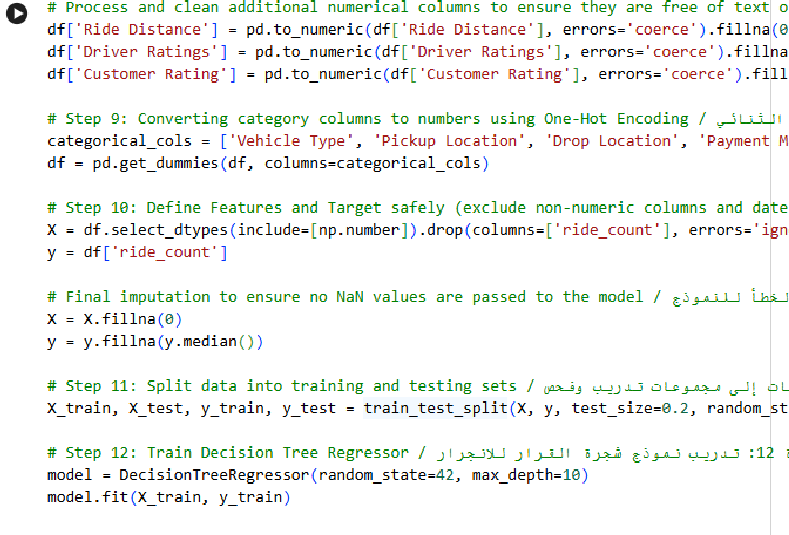
Step 3: Clean numerical columns tep 4: Encode categorical variables, Define features and target and Split data and train model
Categorical columns like Vehicle Type,
Pickup Location, Drop Location, and Payment Method are converted into numerical columns using one-hot encoding. Features (X) and the target variable (y) are then defined safely, including only numeric columns and filling any missing values with 0 for features and the median for the target The data is split into training and testing sets with an 80-20 ratio, and a Decision Tree Regressor with a maximum depth of 10 is trained on the training data.
The data is split into training and testing sets with an 80-20 ratio, and a Decision Tree Regressor with a maximum depth of 10 is trained on the training data.

Step 4: Make predictions and evaluate
The trained model predicts the ride counts for the test data X_test. .
The Mean Absolute Error (MAE) between the predicted values and actual values is calculated to measure performance

Step 5: Performance Metrics: Accuracy, Confusion Matrix, and Classification Report,
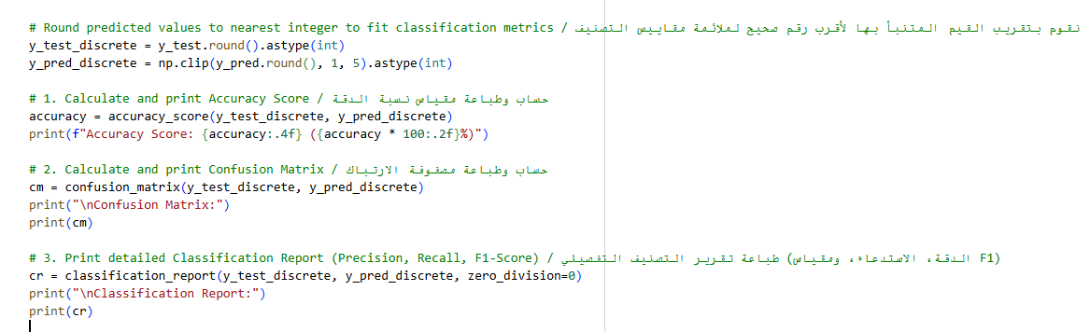
Predicted and actual values are rounded to integers and clipped to a valid range (1 to 5) to match classification metrics. The accuracy score measures the percentage of correct predictions.
The confusion matrix shows the counts of true vs predicted classes
The classification report shows precision, recall, and F1-score for each class This part of the code evaluates the model's performance for classification metrics by

Step6: Plot Confusion
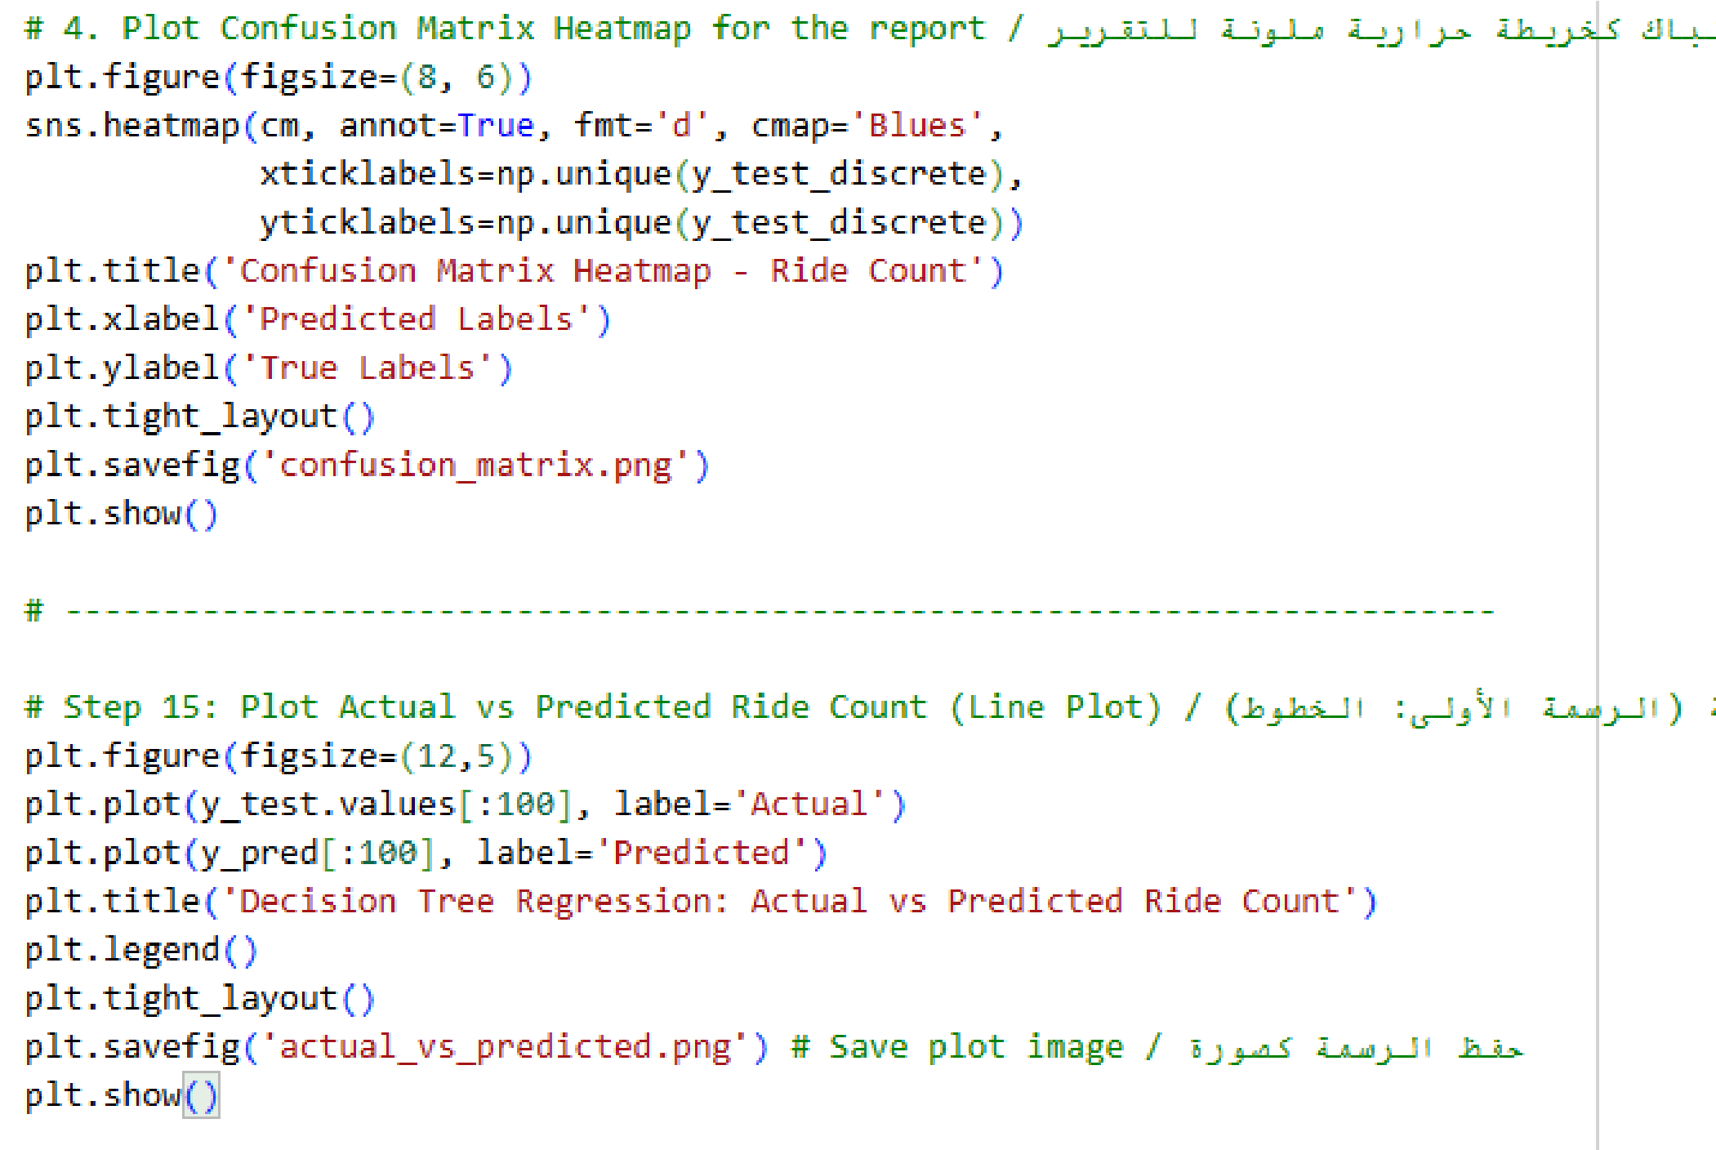
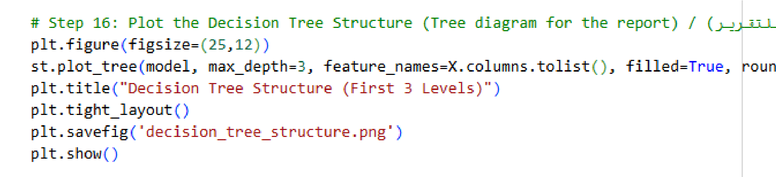


The code creates a heatmap for the confusion matrix to visually show the classification performance. It uses seaborn to plot, labels the axes, sets a title, saves the image as confusion_matrix.png, and displays it.
A line plot is created to compare the actual ride counts (y_test) with the predicted values (y_pred). It sets a figure size, adds a legend, title, tight layout, saves the plot as actual_vs_predicted.png, and displays it. This section generates visual reports: a heatmap for the confusion matrix to evaluate classification accuracy and a line plot to compare actual versus predicted ride counts, saving both images for reference.
This section visualizes the structure of the trained Decision Tree. A diagram is plotted showing the first 3 levels of the tree with feature names, filled colors, rounded nodes, and font size adjustments. The figure is saved as decision_tree_structure.png and displayed.

Outputs
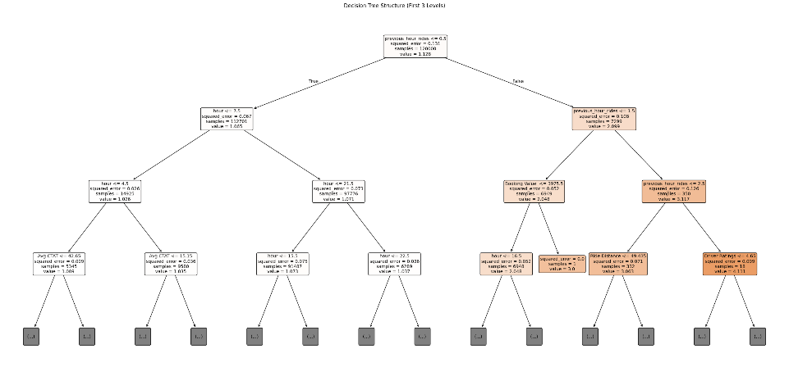

The Decision Tree Structure shown in the figure represents how the machine learning model predicts the number of Uber rides based on the dataset features used in the code.
The model was trained using several input variables such as:
- hour of the day,
- day of the week,
- weekend indicator,
- previous hour rides,
- ride distance,
- driver ratings,
- customer rating,
- vehicle type,
- pickup location,
- drop location,
- and payment method.
The tree starts from the root node at the top, where the model applies the first condition to split the dataset into smaller groups. Each branch represents a decision based on feature values. For example, the model may divide rides according to the pickup location, ride demand in previous hours, or time of the day.
As the tree continues downward, more conditions are applied to improve prediction accuracy. Each internal node represents a new rule used to separate the data into more specific ride patterns.
The leaf nodes at the bottom represent the final predicted ride count generated by the model.
The colors inside the nodes indicate the prediction intensity and data distribution, where darker colors generally represent stronger or more confident predictions.
Overall, the decision tree helps visualize how the model analyzes Uber ride data step by step to predict ride demand using the features extracted and processed in the Python code.

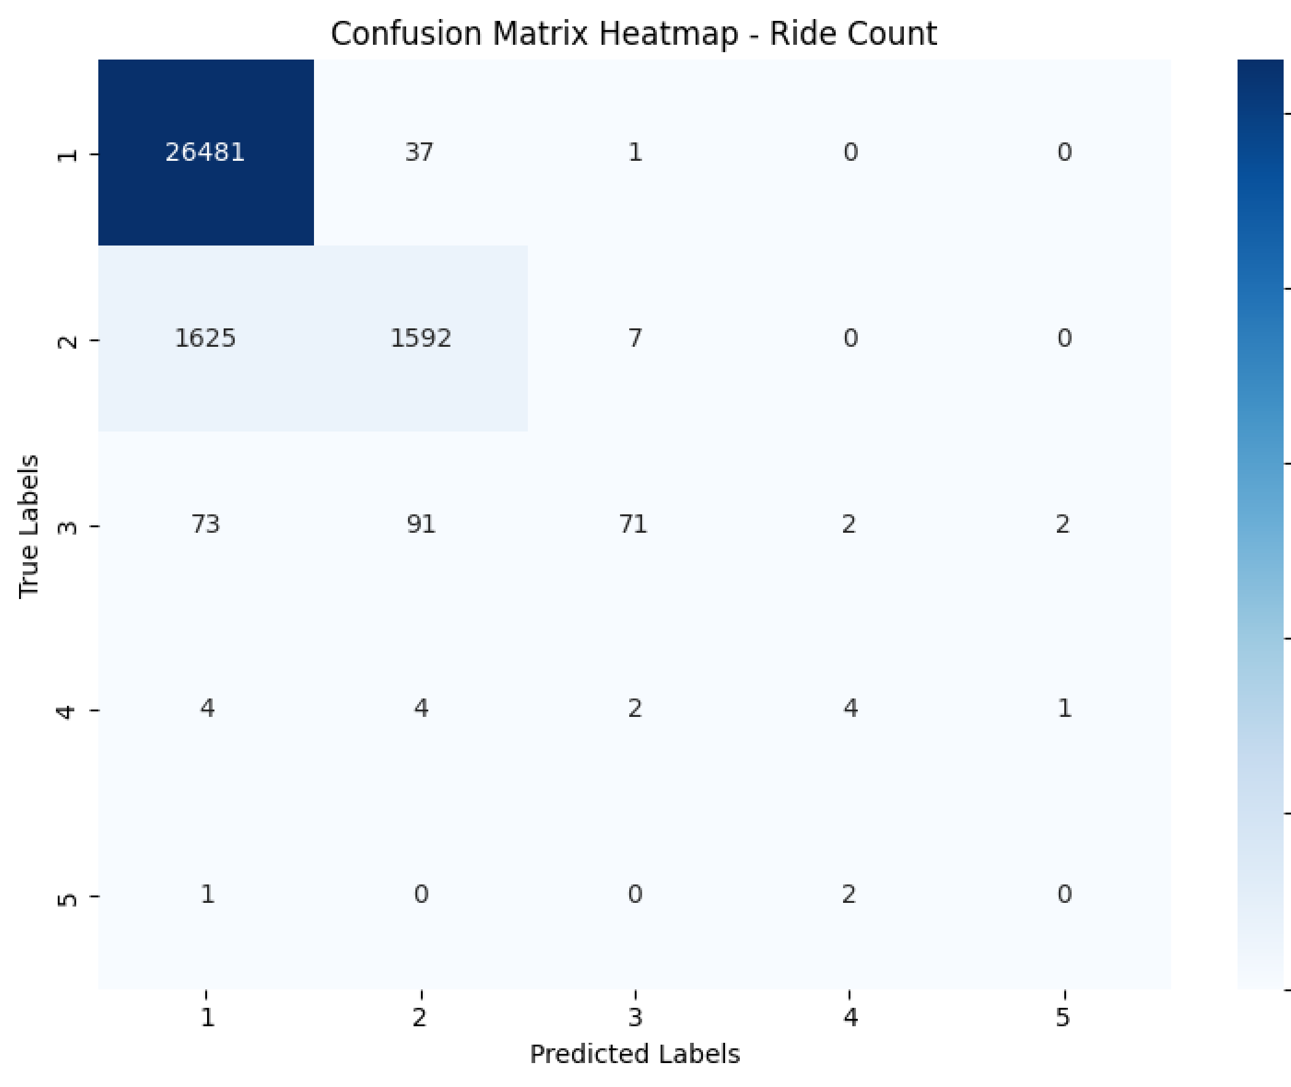

The figure represents the Confusion Matrix Heatmap used to evaluate the performance of the Decision Tree model in predicting ride counts.
The rows represent the true labels (actual ride counts), while the columns represent the predicted labels generated by the model.
The diagonal values in the matrix represent correct predictions made by the model. For example:
- The model correctly predicted class 1 rides 26,481 times.
- It correctly predicted class 2 rides 1,592 times.
- It correctly predicted class 3 rides 71 times.
The off-diagonal values represent prediction errors where the model predicted a different ride count than the actual value. For instance:
- Some actual class 2 rides were incorrectly predicted as class 1.
- A few class 3 rides were predicted as class 2 or class 4.
The darker blue color indicates higher prediction frequency, meaning the model performs better in those categories.
Based on the heatmap, the model achieved strong performance in predicting lower ride count classes, especially class 1, while prediction accuracy decreases slightly for higher ride count classes due to fewer available samples in the dataset.
Overall, the confusion matrix provides a visual representation of the model’s prediction accuracy and classification errors across different ride count categories.
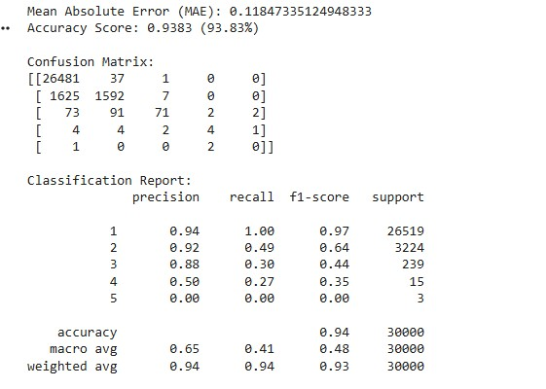

The performance evaluation results indicate that the Decision Tree model achieved strong predictive performance in estimating ride counts. The model obtained a Mean Absolute Error (MAE) of 0.118, which indicates that the average prediction error is very low. In addition, the model achieved an Accuracy Score of 93.83%, demonstrating its ability to correctly predict ride count categories in most cases.
The confusion matrix shows that the model performed exceptionally well for Class 1, correctly classifying 26,481 out of 26,519 instances. The performance for Class 2 was also acceptable, with 1,592 correct predictions out of 3,224 instances. However, the accuracy gradually decreased for Classes 3, 4, and 5 due to the limited number of samples available in these categories.
The classification report further confirms these findings. Class 1 achieved the highest performance with a Precision of 0.94, Recall of 1.00, and F1-Score of 0.97. The weighted average values of Precision (0.94), Recall (0.94), and F1-Score (0.93) indicate that the model provides reliable and consistent predictions overall.
The lower performance observed in higher ride-count classes is mainly attributed to class imbalance in the dataset, where the majority of observations belong to Class 1. Despite this limitation, the model demonstrates strong overall predictive capability and can effectively support ride demand forecasting based on the selected features

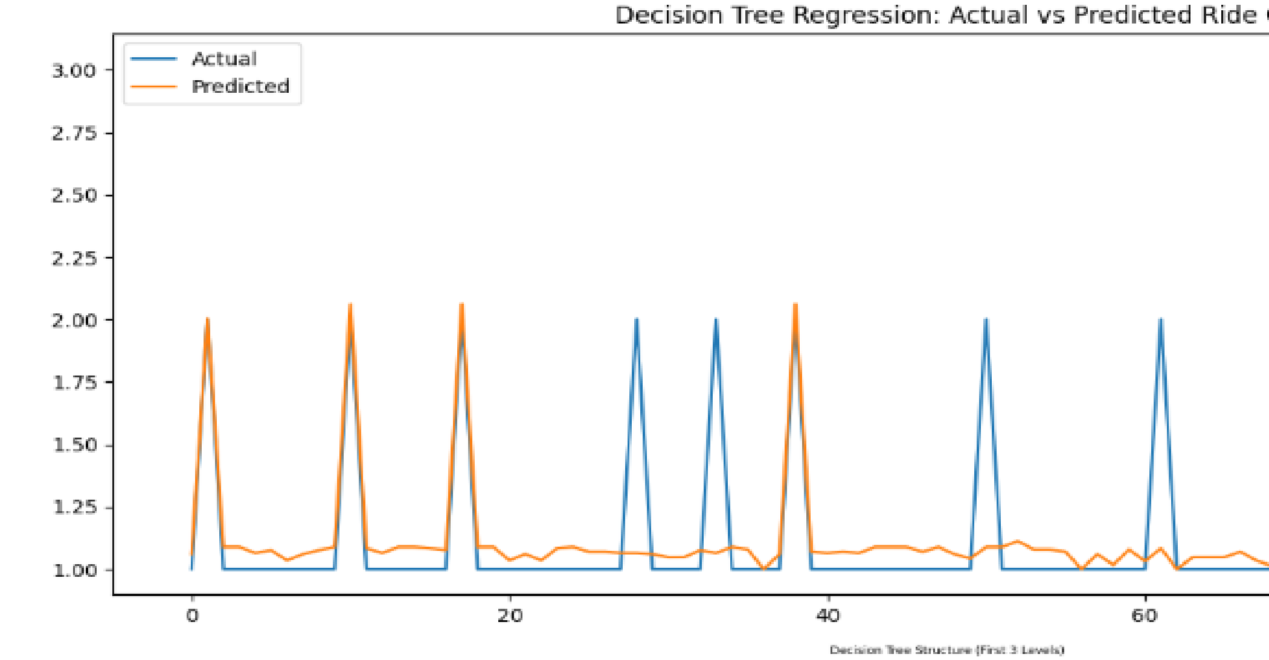

The figure illustrates the comparison between the actual ride counts and the predicted ride counts generated by the Decision Tree Regression model.
The blue line represents the actual ride count values from the dataset, while the orange line represents the predicted values produced by the model.
The graph shows that the predicted values generally follow the same pattern as the actual values, indicating that the model was able to capture the ride demand behavior effectively. In many cases, the predicted values closely match the actual ride counts, especially for the most frequent ride count levels.
Some differences between the two lines can be observed at certain points where the model slightly underestimates or overestimates the ride count. These variations are expected due to the complexity and variability of ride demand patterns.
Overall, the close alignment between the actual and predicted lines demonstrates that the Decision Tree Regression model achieved good predictive performance and was successful in estimating ride counts based on the selected dataset features such as time, location, ratings, ride distance, and previous ride activity.
Predicting the status of an Uber trip:
Will it be completed successfully or canceled? Driving on passenger data
(such as trip time, distance, ratings, payment method, and pick-up location)
Classification
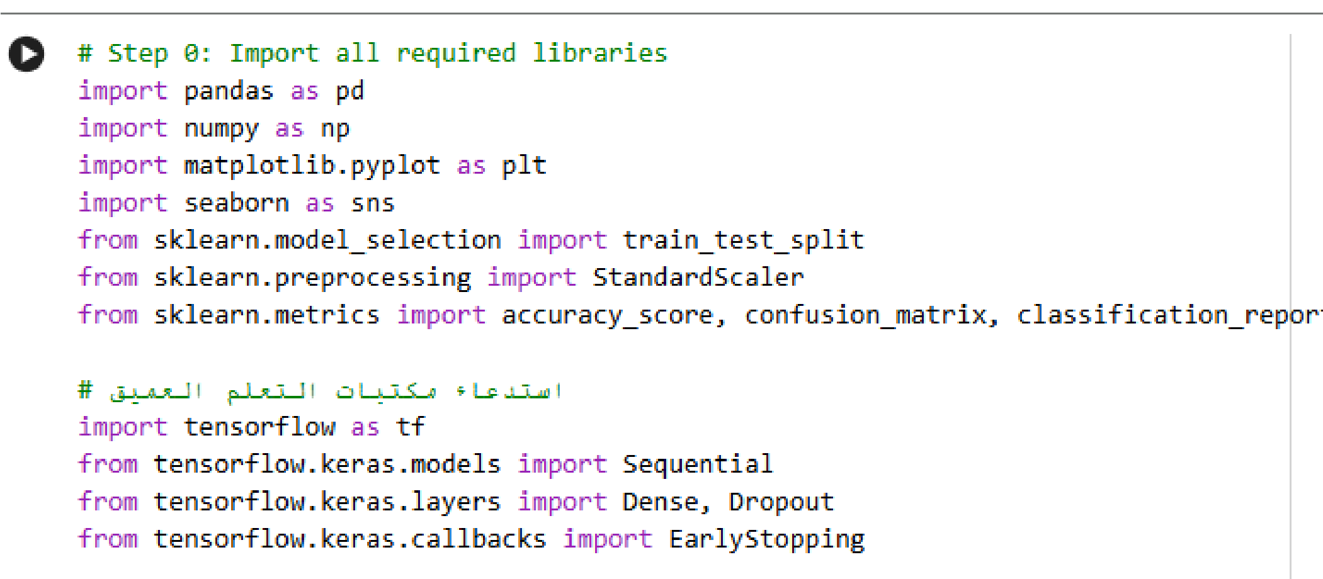
Step 1: Import all required libraries
his section sets up all necessary tools to preprocess data, visualize it, split it into train/test sets, evaluate models, and build a deep learning neural network using Keras. The code imports basic libraries for data handling (pandas, numpy), visualization (matplotlib, seaborn), and machine learning preprocessing and metrics (train_test_split, StandardScaler, accuracy_score, confusion_matrix, classification_report). The code imports TensorFlow as tf and
Keras modules: Sequential for building sequential models, Dense for fully connected layers, Dropout for regularization, and EarlyStopping callback to prevent overfitting.

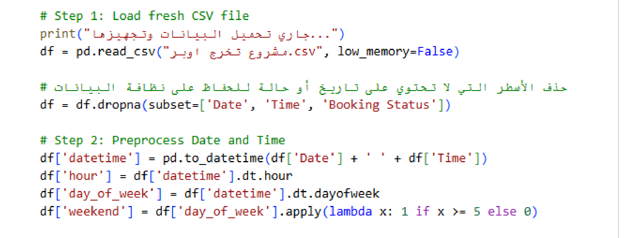
Step 2: Load fresh CSV file, Preprocess Date and Time

This part loads the CSV file, removes incomplete rows, and creates new features from the date and time to prepare the
dataset for model training.
The code prints a message to indicate that the CSV file is being loaded. Then it reads
the CSV file (مشروع تخرج.csv) into a pandas DataFrame, with low_memory=False to prevent memory issues for large files. Rows with missing values in Date, Time, or Booking Status are removed to ensure data quality
The Date and Time columns are combined into a new datetime column

Step 3: Create the Classification Target and Clean numeric columns
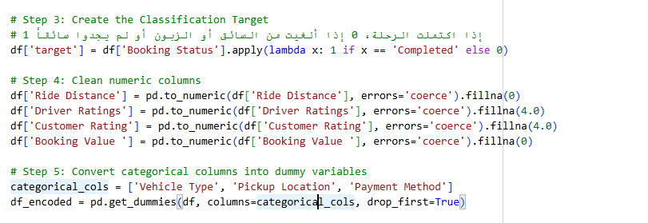
Categorical columns Vehicle Type, Pickup Location, and Payment Method are converted into one-hot encoded dummy variables, with the first category dropped to avoid multicollinearity.
Numeric columns such as Ride Distance, Driver Ratings, Customer Rating, and
Booking Value are converted to numeric
types. Any invalid entries are coerced to NaN and then filled with default values (0 for distance and booking value, 4.0 for ratings).

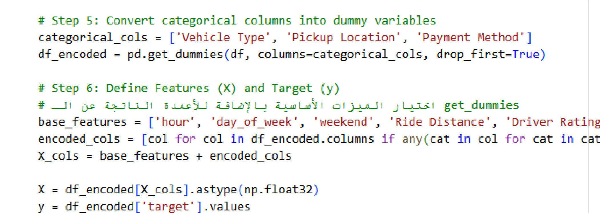
Step 4: Convert categorical columns into dummy variables and Define Features (X) and Target (y)
Base features are numeric and previously engineered (hour, day_of_week, weekend, Ride Distance, Driver Ratings, Customer Rating, Booking Value). Encoded categorical columns are added. Features X are selected and converted to float32, and the target y is the target column.
Categorical columns Vehicle Type, Pickup Location, and Payment Method are converted into one-hot encoded dummy variables, with the first category dropped to avoid multicollinearity.
These steps create the classification target, clean numeric columns, encode categorical variables, and prepare the feature matrix X
Step 5: Split data into training and testing sets and Data Scaling
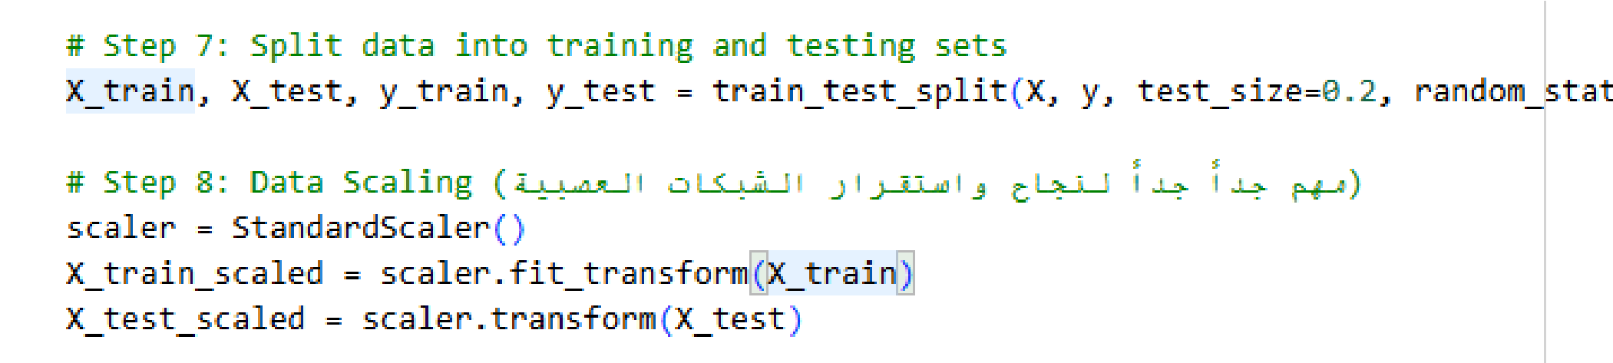

The features X and target y are split into training and testing sets using an 80-20 ratio (test_size=0.2). random_state=42 ensures reproducibility of the split.
A StandardScaler is used to normalize the feature values. The scaler is fitted on the training set and transforms both training and testing sets. This step is important for deep learning models to converge properly.
This part splits the dataset into training and testing sets and scales the feature values, preparing the data for training a deep learning model.
Step 6: Build the Neural Network Architecture
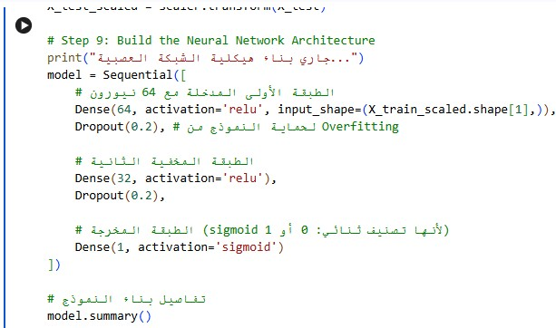

The code prints a message indicating that the neural network is being built. A Sequential Keras model is created with three layers: the first dense layer has 64 neurons with ReLU activation and a Dropout layer (0.2) to prevent overfitting. The second dense layer has 32 neurons with ReLU activation and another Dropout layer. The output layer has 1 neuron with sigmoid activation because this is a binary classification problem
Step 7: Compile the Model, Train the Neural Network, Evaluate Model on Test Data
sigmoid activation because this is a binary classification problem.

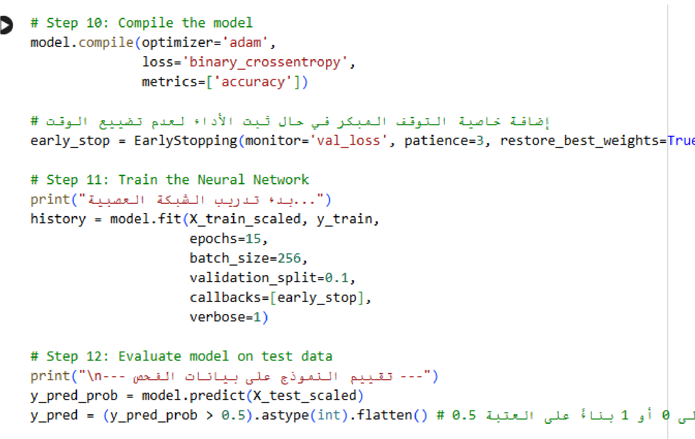
Step 7: Compile the Model, Train the Neural Network, Evaluate Model on Test Data

EarlyStopping monitors validation loss and stops training if it does not improve for 3 consecutive epochs. The best weights are restored automatically.
The model is trained on the scaled training data with a batch size of 256, for up to 15 epochs, and a validation split of 0.1. EarlyStopping is applied to prevent overfitting.
Predictions are made on the scaled test set. Probabilities are converted to binary class predictions: if >0.5, the output is 1; otherwise, 0.
This section compiles the neural network, trains it with early stopping to prevent overfitting, and evaluates the predictions on the test set by converting probabilities into binary class outputs.

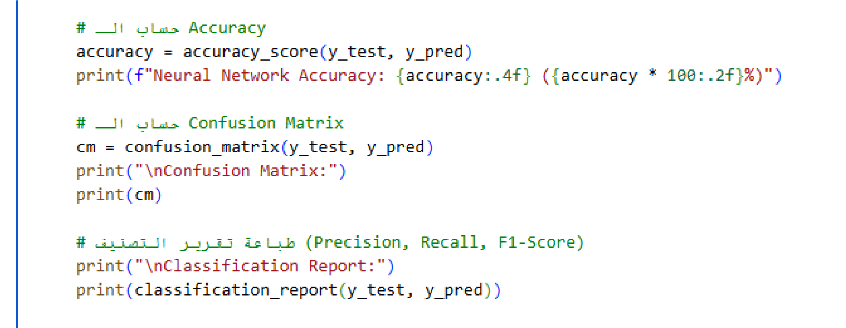
Step 8: Calculate Accuracy, Compute Confusion Matrix, Print Classification Report

The accuracy of the neural network is calculated by comparing the predicted labels y_pred with the actual test labels y_test. The result is printed as a percentage. A confusion matrix is computed to visualize how many samples were correctly or incorrectly classified.
A detailed classification report is printed showing precision, recall, F1-score, and support for each class. This section evaluates the trained neural network by calculating its accuracy, showing thconfusionmatrix, and printing detailed classification report with precision, recall, and F1-scores for each class.

Step 9: Plot Training
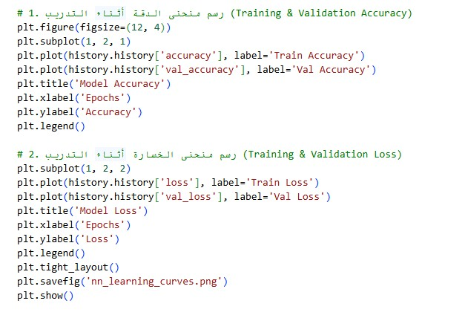
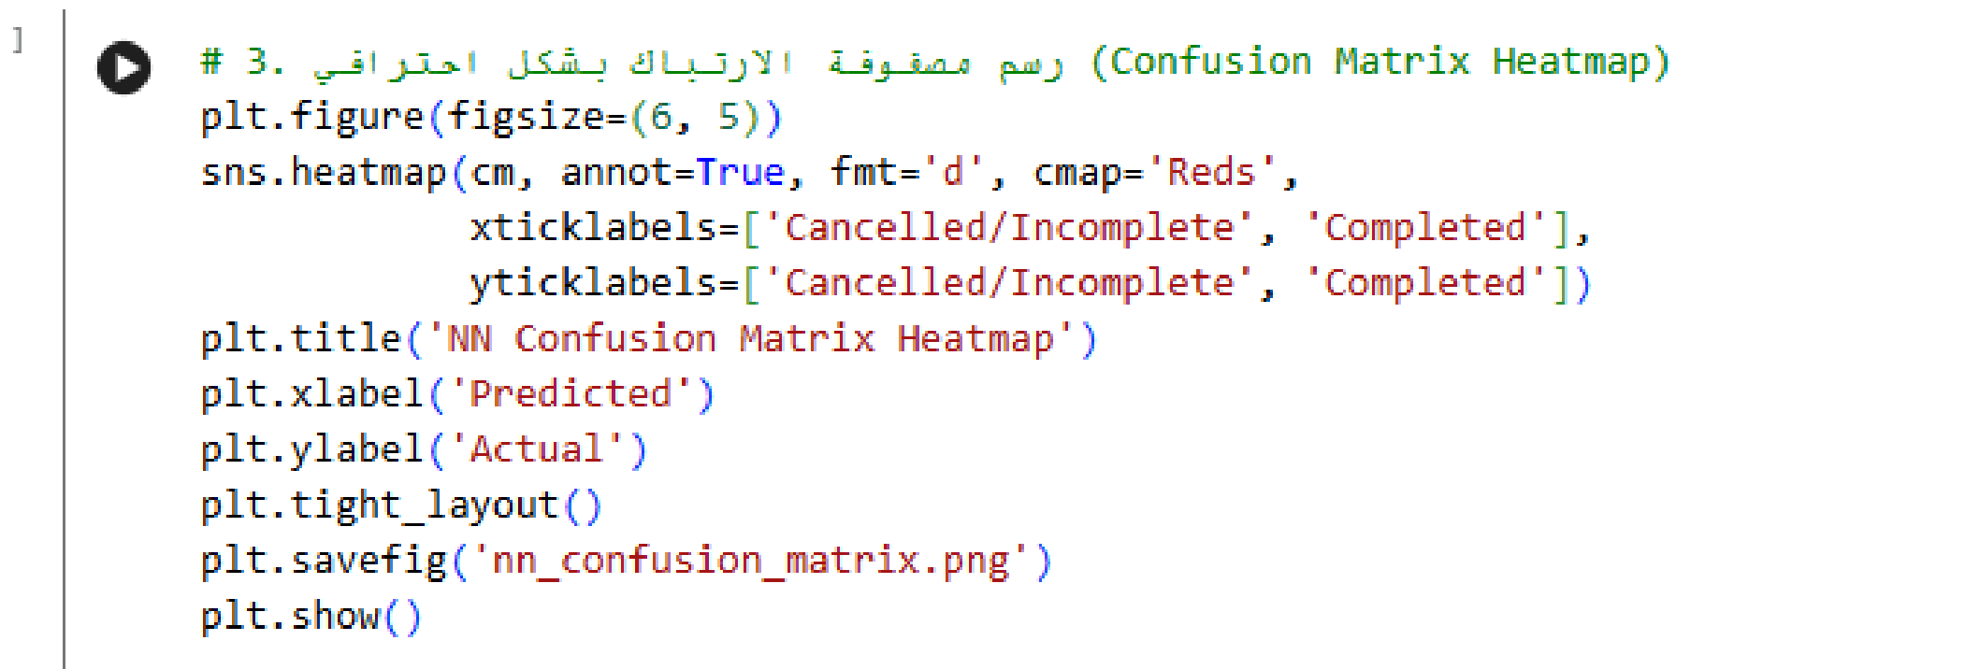

A line plot shows the training and validation accuracy over epochs. This helps visualize how well the model learns and whether it overfits.
Another subplot shows the training and validation loss curves, helping to monitor model convergence and detect overfitting. A heatmap of the neural network confusion matrix is plotted using seaborn with a red color map. The axes are labeled with 'Cancelled/Incomplete' and 'Completed', and the figure is saved as
'nn_confusion_matrix.png'.
This section visualizes the performance of the trained neural network. It includes: training & validation accuracy, training & validation loss curves, and a confusion matrix heatmap. These plots help evaluate learning, detect overfitting, and analyze classification results.

Outputs
Confusion Matrix:
[[3167 28]
[ 41 5306]
Classification Report:
precision recall f1-score support

- 0.99 0.99 0.99 3195
- 0.99 0.99 0.99 5347
The confusion matrix and classification report demonstrate that the Neural Network model achieved excellent classification performance in predicting booking status (Completed or Cancelled/Incomplete).
According to the confusion matrix:
- The model correctly classified 3,167 cancelled or incomplete bookings.
- It also correctly classified 5,306 completed bookings.
- Only a small number of predictions were incorrect, with 28 false positives and 41 false negatives.
The classification report shows very high evaluation metrics for both classes:
- Class 0 achieved Precision = 0.99, Recall = 0.99, and F1-Score = 0.99.
- Class 1 also achieved Precision = 0.99, Recall = 0.99, and F1-Score = 0.99.
These results indicate that the Neural Network model was highly effective in distinguishing between completed and cancelled bookings with very high reliability and consistency.
Overall, the model demonstrates strong predictive capability and excellent generalization performance, making it suitable for booking status prediction using features such as ride distance, customer ratings, driver ratings, booking value, time-related features, vehicle type, pickup location, and payment method

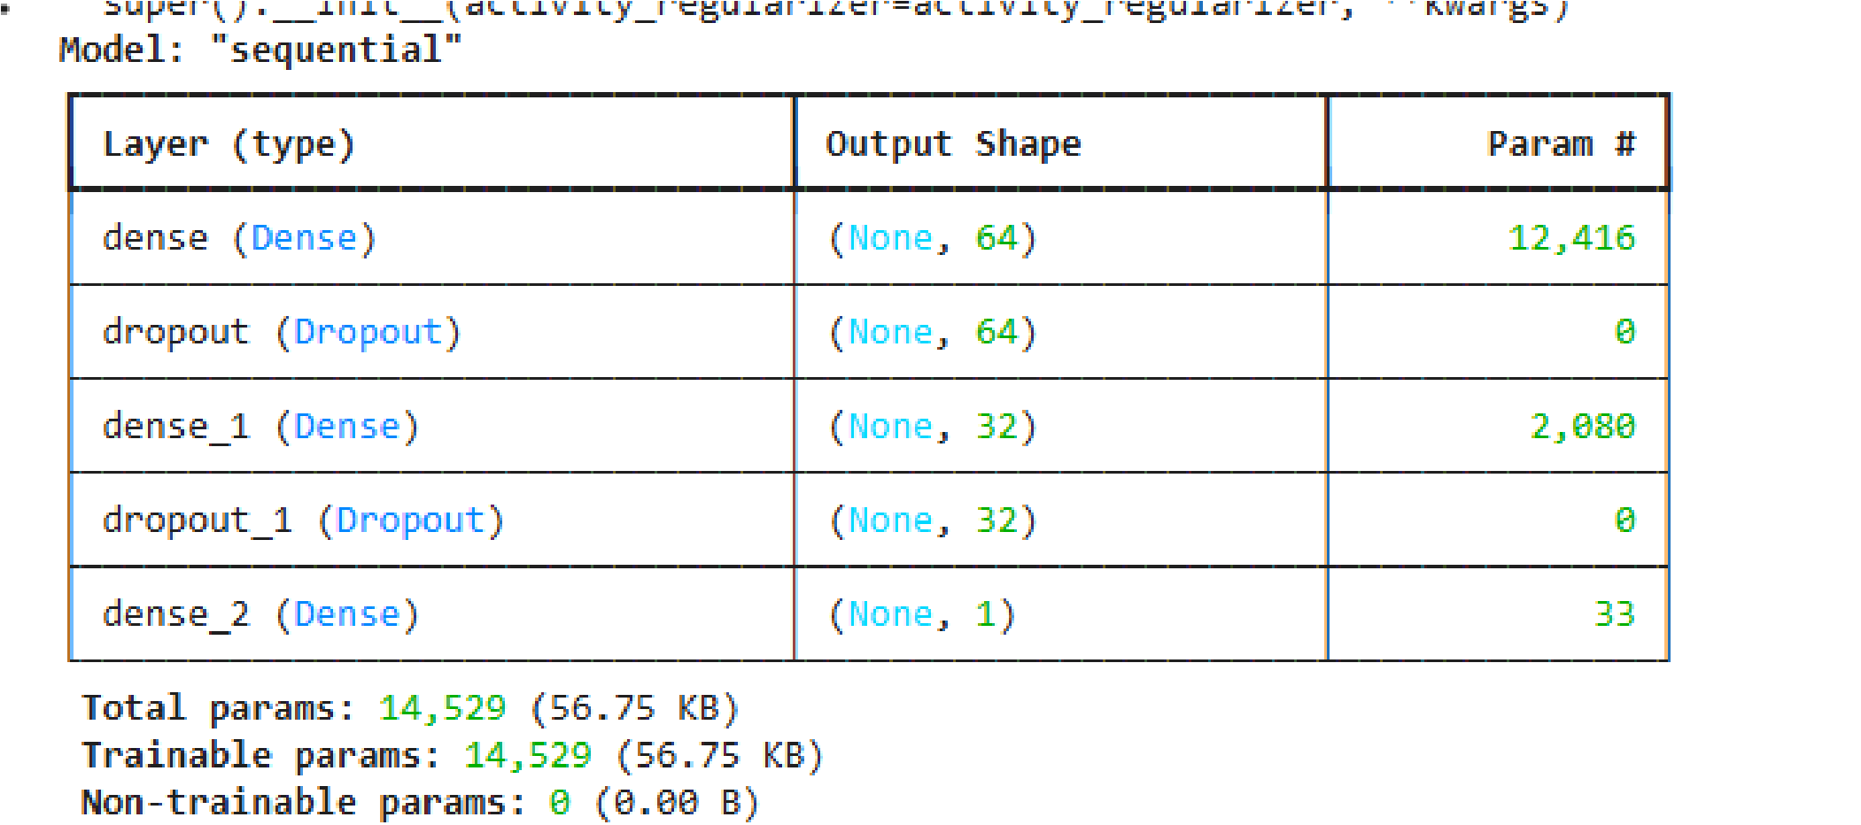
The figure presents the architecture summary of the Sequential Neural Network model used for booking status prediction. The model consists of multiple layers designed to learn patterns from the Uber dataset features.
The first layer is a Dense layer containing 64 neurons, which receives the input features and learns the initial relationships between variables. This layer contains 12,416 trainable parameters.
After the first dense layer, a Dropout layer is applied to reduce overfitting by randomly disabling a portion of neurons during training, helping the model generalize better on unseen data.
The second hidden layer is another Dense layer with 32 neurons and 2,080 trainable parameters, allowing the network to learn more complex patterns and feature interactions. Another dropout layer follows for additional regularization.
The final output layer contains 1 neuron with a sigmoid activation function, which is suitable for binary classification tasks such as predicting whether a booking is completed or cancelled/incomplete. This output layer contains 33 trainable parameters.
In total, the neural network contains 14,529 trainable parameters, all of which are updated during the training process to improve prediction accuracy.
Overall, the architecture demonstrates a balanced neural network design that combines feature learning and overfitting prevention techniques to achieve high classification performance on the booking status prediction task.

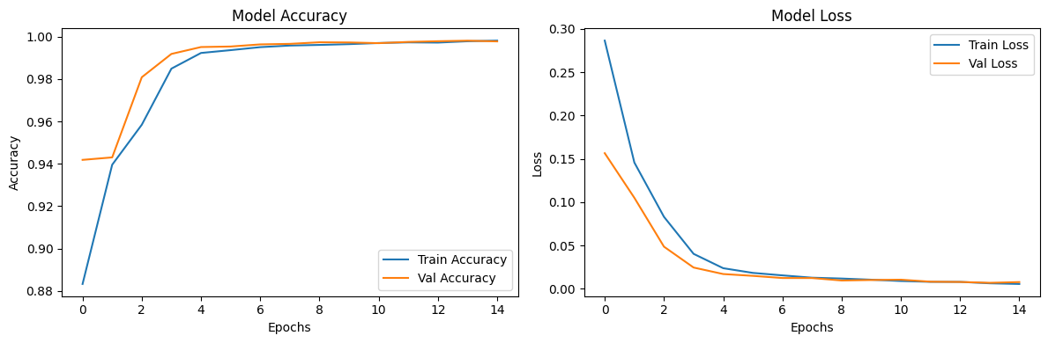

The figure illustrates the training performance of the Neural Network model through two important evaluation metrics: Accuracy and Loss over multiple training epochs.
The graph on the left shows the model accuracy for both the training data and validation data. The training accuracy increased rapidly from approximately 88% in the first epoch to nearly 99% after several epochs. Similarly, the validation accuracy also improved steadily and remained very close to the training accuracy throughout the training process. This indicates that the model learned the data patterns effectively and achieved excellent predictive performance without significant overfitting.
The graph on the right represents the model loss for both training and validation datasets. The loss values decreased significantly as the number of epochs increased, dropping from relatively high values at the beginning to values close to zero at the final epochs. The similarity between training loss and validation loss curves suggests that the model generalized well to unseen data and maintained stable learning behavior.
Overall, the learning curves demonstrate that the Neural Network model achieved high accuracy, low loss, and stable convergence during training, confirming the effectiveness of the selected architecture and preprocessing techniques for booking status prediction.

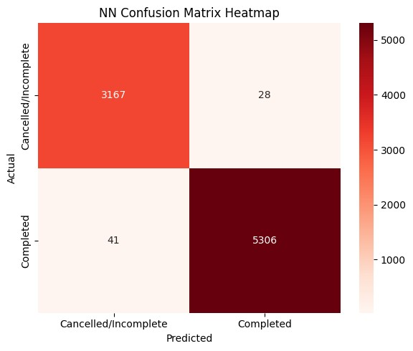

The figure represents the Neural Network Confusion Matrix Heatmap, which visualizes the classification performance of the neural network model in predicting booking status as either Completed or Cancelled/Incomplete.
The rows represent the actual booking status values, while the columns represent the predicted values generated by the model.
The heatmap shows that the model correctly classified:
- 3,167 cancelled or incomplete bookings.
- 5,306 completed bookings.
Only a small number of predictions were misclassified:
- 28 cancelled/incomplete bookings were incorrectly predicted as completed.
- 41 completed bookings were incorrectly predicted as cancelled/incomplete.
The darker red color indicates higher prediction frequency and stronger model performance in those categories. The large values along the diagonal confirm that the neural network achieved very high classification accuracy with minimal prediction errors.
Overall, the confusion matrix demonstrates that the neural network model was highly effective in distinguishing between completed and cancelled bookings, confirming the reliability and robustness of the model for booking status prediction tasks.

